Generalities
Can we pin down some dates for all these Image contents or letters??
For dates, use this order of preference, but anything is better than nothing!
- Year, Month, day of Image contents
- Our Age in Years, Months
- Our Age in Years, Months
- Our Age in Years, Circa
- Our Grade in School

The dates within the light blue Heading 1 es are our best estimates of date range the vehicle was owned by us.

Dates should be consistent with this:

June '48 end 4th Grade (Fred in Indy)

June '51 end 7th Grade (Fred in Indy)
June '52 end 8th Grade (Fred in Gary)

June '53 end freshman year (Fred back in Indy)
June '54 end sophomore year
June '55 end junior year
June '56 end senior year

Wooden Frame Motor Car (Rusty's)
This car had a rectangular wooden frame, built out of 2 by 6es or something. The front wheels, with hard rubber, not inflatable, tires were attached to the frame via standard iron plumbing pipe parts! They could steer because of a 90º angle pipe fitting that went horizontally to the wheel and vertically to a plumbing flange screw onto the wooden frame! It had a 2 cylinder Washing Machine Engine, and pulleys with v-belts for the drive. IIRC the motor was on a spring loaded slider for the clutch.
Rusty wrote on 11, 2019, 1:07 PM
….Before the doodlebug I had a little motor car with a washing machine engine. It must have been when we were in grade school.

Doodle Bug (Rusty's) 1948circa to 1950circa
Like Motor Car, I'm beginning to suspect that the Doodle Bug was another thing Dr. Sage heard about at work, then somehow got to the turnaround for Rusty and friends to play with. The Doodlebug must have been around for 2 -3 three years, because IIRC it disappeared for a long time and showed up, running, under the Christmas tree with the motor rebuilt?
Doodle bug with the plumbing exhaust pipe that glowed red when followed red on a Midnight Ride.

Indian (Rusty & Fred's?) 19?? to 19??
Tue, Jan 15, 3:28 PM
The story was something like that one. But it seems to me is was about and Indian not a Harley.
On Jan 15, 2019, at 12:23 PM, Frederick N. Chase <fchase@gmail.com> wrote:
Is this by any chance it?? A Harley, not an Indian?
https://www.huffingtonpost.com/2012/10/19/ed-church-motorcycle-ebay_n_1987850.html
https://www.youtube.com/watch?v=4M8c46pZH1c

On Tue, Jan 15, 2019 at 1:46 PM Russell Sage <russosago@gmail.com> wrote:
All I remember is I sent you the link so if it doesn’t work now it must have been deleted or changed. Sorry, but I can’t help…
On Jan 15, 2019, at 11:35 AM, Frederick N. Chase <fchase@gmail.com> wrote:
Rusty, in Jan 2-19, this site can't be reached.
I wonder if mobiledia should instead have been mobilemedia or something.
I don't think I ever saw your reference.
Did we own the Indian jointly?
I can't seem to find any picture anywhere that looks like it.

On Mon, Sep 22, 2014 at 4:13 PM Russell Sage <russosago@gmail.com> wrote:
Fred, is the way you felt about our Indian?
The One That Got Away
http://www.mobiledia.com/news/189235.html

Little Car (Gregory's)

Gary, Indiana (Fred) summer, 1951 to Feb, 1953
We built a new home at 220 West 44th Avenue. It was on the front lawn of the big old house my father had lived in when he was a kid. Fred went to Lew Wallace for our 8th Grade and half of our 9th Grade. After his 8th grade (1951/52) his father died (July 16, 1952) He spent a semester (Sept 1952 to Feb 1953) as a freshman in Gary before Louise & children moved back to Indianapolis Feb 1953 to 709 East 73rd Street. Fred didn't have a Travis or whizzer while in Gary. When they came back Louise bought the house at 709 E. 73rd St. (Just East of College Avenue.)

Travis (Fred) spring, 1953 to late 1953 or early 1954
Travis 2-stroke motorbike (with the stone roller that rolled on the front tire to transmit the power). Later I stuffed brillo pads into the muffler. A husband on College Avenue requested it for his wife, 'cause it had been so buzzy going by all the time from 73rd St to 86xx th St.
It is a fact that the Travis must have been after I came back from Gary. So Fred got his Travis NO EARLIER than Feb 1953.
In the spring of 1953 I finished, at BRHS, the second half of the 9th grade and probably got my Travis then.

Travis (Carl) summer, 1953 to ?
Jan 11, 2019, 1:55 PM gmail
"I got a Travis after you, Fred, ….".
Carl says "Was impressed with your Travis, so my parents bought me one."

Vespa (Alan Figel) 1954 Circa?
Carl Feb 13, 2019, 10:20 AM: "I'm fairly sure Allen Figel had a Vespa."
Fred replied: "I know he did! I remember him showing up with it, almost brand new!! I was very jealous. IIRC, none of 'the rest of us' had anything like it (no Travises, no Doodlebugs, no Whizzers ??) and I wanted to try it but I was hesitant to ask. I think finally I did try it very briefly. You pulled in the clutch and twisted that handlebar to change between 1, 2, or 3rd gear.

Cushman (Bill Kothe) 1954 circa?
Carl Feb 13, 2019, 10:20 AM: "Bill Kothe had a Cushman made by Sears & Roebuck with a Briggs & Stratton engine"

Whizzer (Fred) late 1953 or early 1954 to spring 1955
Whizzer, with that beautiful chromed exhaust pipe and deep manly mellow sound.
On Jan 13, 2013, at 4:01 PM, Frederick N. Chase wrote:
"Blow right through ... stop signs" ------
Carl's been thinkin he's at the top of the pyramid since childhood! Hubris.

Proof a
Proof b

Whizzer (Carl) summer 1954 to ??
I bought my Whizzer probably in the summer of 54', used. For $10.
On Jan 11, 2019, 1:55 PM from: PETERS CARL L <clpeters2@sbcglobal.net>date:
"I bought my Whizzer probably in the summer of 54', used, from Gil Berry, a year ahead of us at Broad Ripple HS.
Gil was initially my boss in the prosecutor's office. He was a heavy drinker and smoker, gave up drinking, but not the cigarettes and died of throat cancer several years ago.
His funeral was at that funeral home on 86th Street just west of the Sage farm. At his services, there was an open bar!!
He was really a good guy."

Louise's '56 Ford Fairlane hardtop convertible (Fred) Sept. 1955 to ?

BMW R25-2 (Fred)
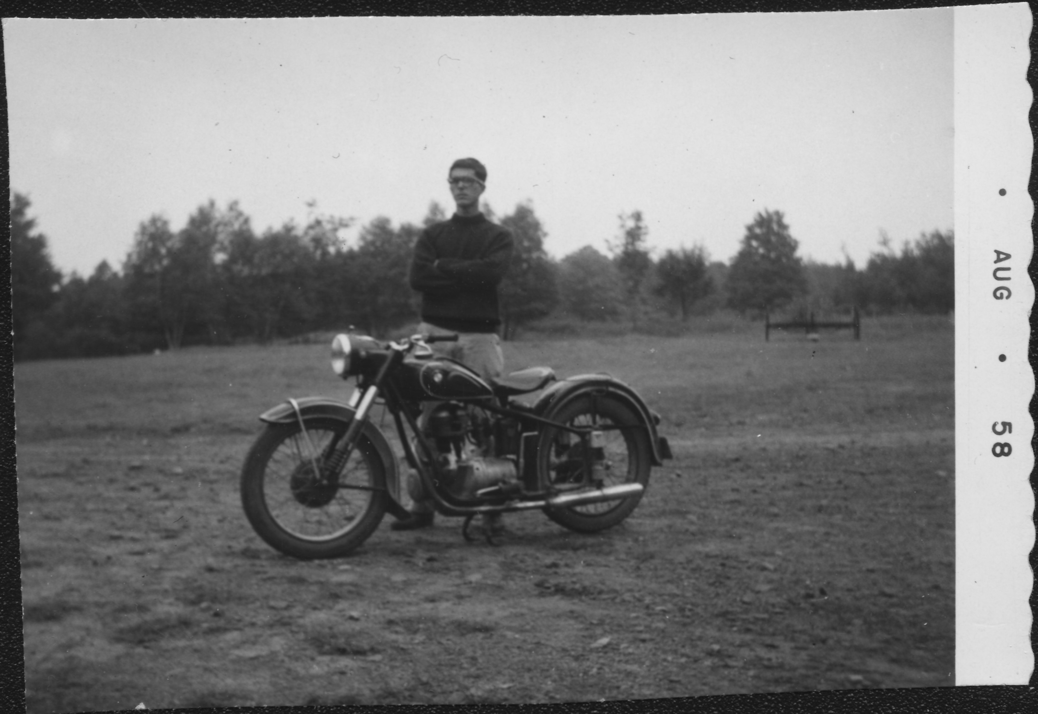
More specifics on this one at C:\Micron_F\httpdocs\Archive\Chase-Frederick_Noel\BMW R25 2\My BMW R25 2 Single.pdf

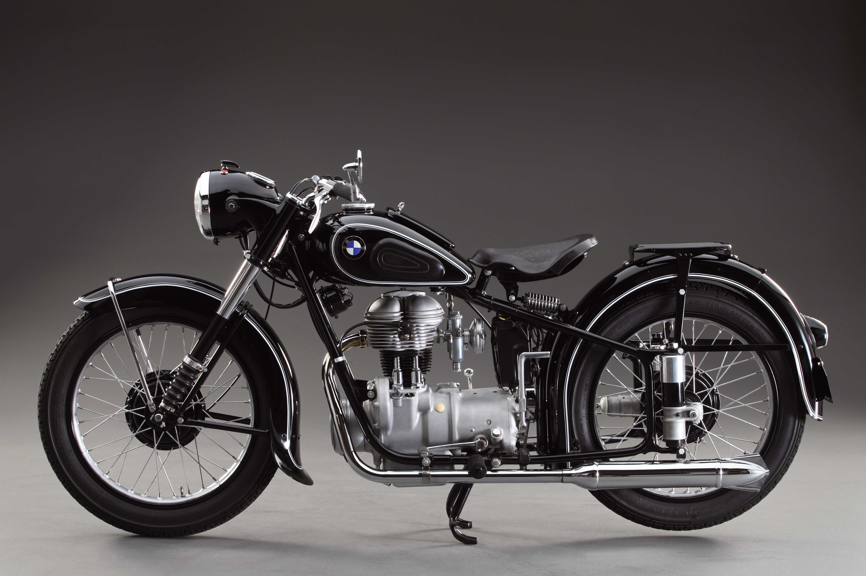
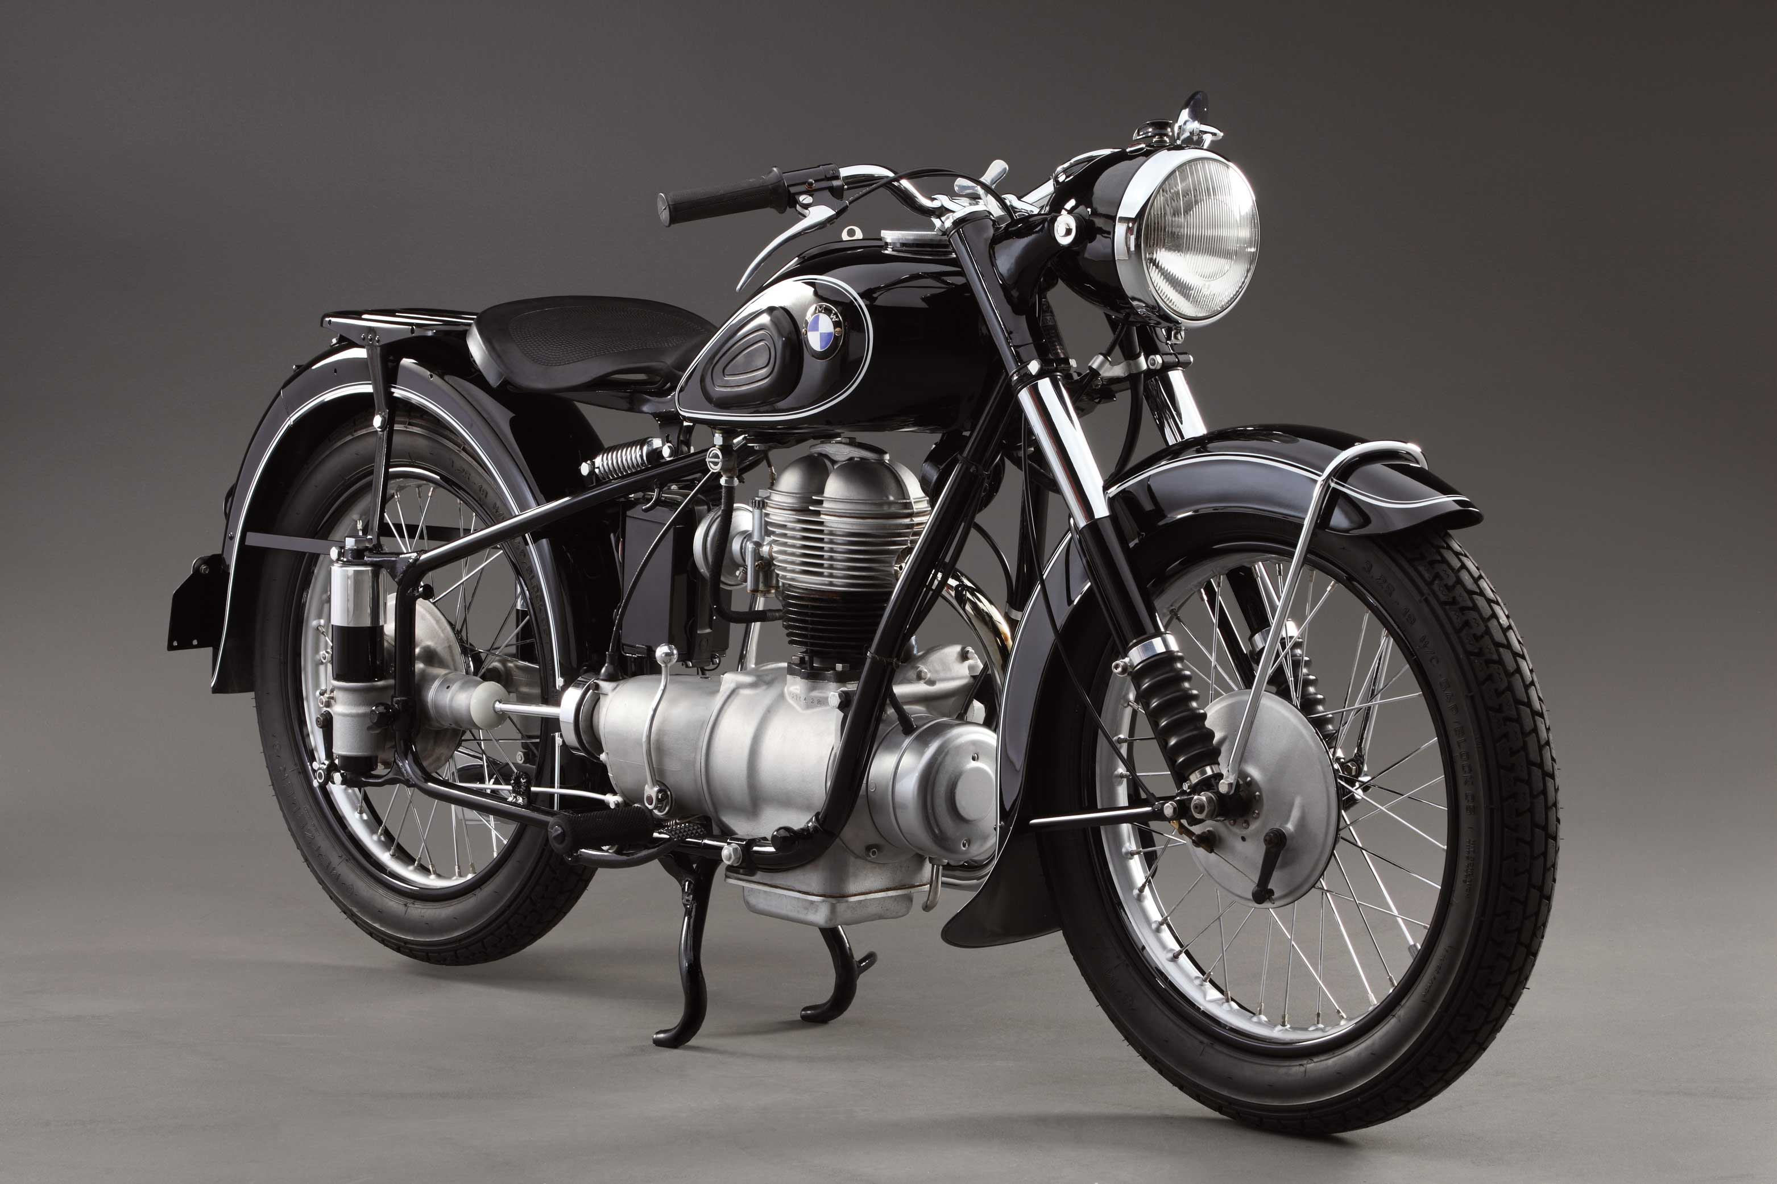

Honda Trail '50's (Russ, Carl, later Fred) circa 1963?
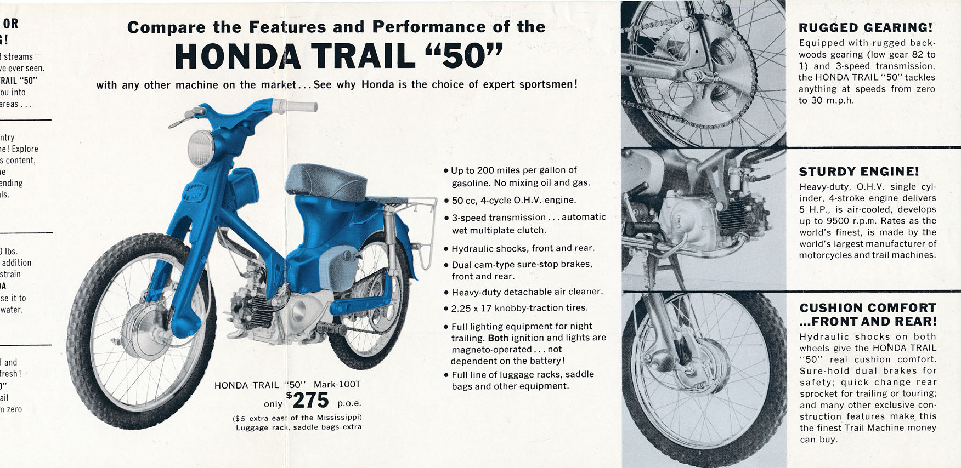
The image above is from Elmo's Cyclery in Ogden Utah. Sara and I lived in Salt Lake Sept 1962 to June 1964, IIRC. -Fred

Rusty: Don’t remember when I acquired the Doodle Bug. I remember the first time I rode the Honda trail 50 I was in Brown County and was riding in the yard by our house when my handle bars suddenly pulled off on one side and I went down and smashed a finger. I guess it hadn’t been screwed on tight when it was assembled.

Yamaha Trailmaster MG1-T 80 cc (Fred) circa 1963
Fred at Interlochen 1963.
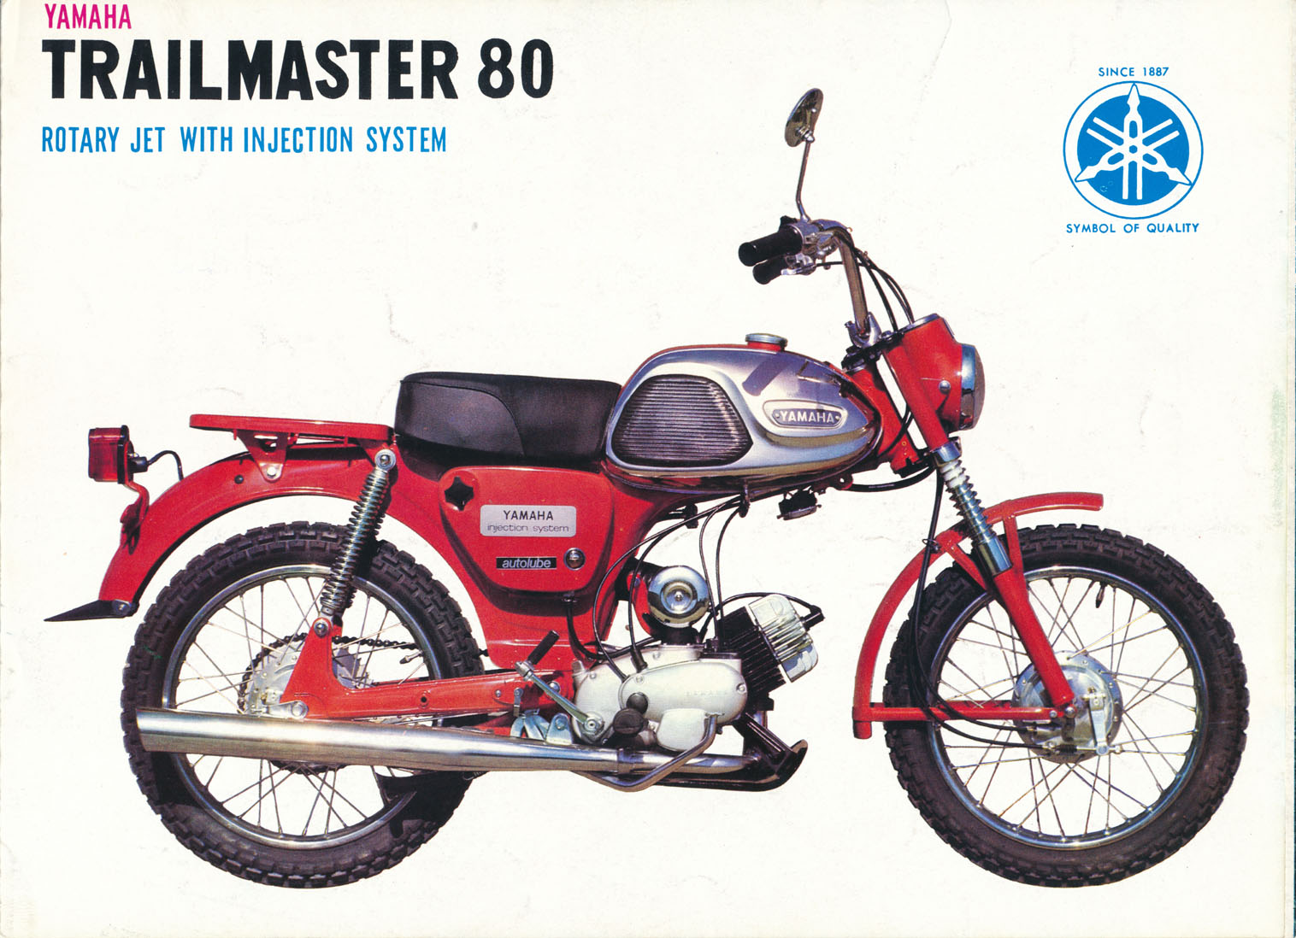
These had oil injection (variable oil mixture, so didn't smoke much!! There was also a Trailmaster 80 YG1-T – a step-through.

Honda CB77 Super Hawk 305cc (Fred) 1972 to ?
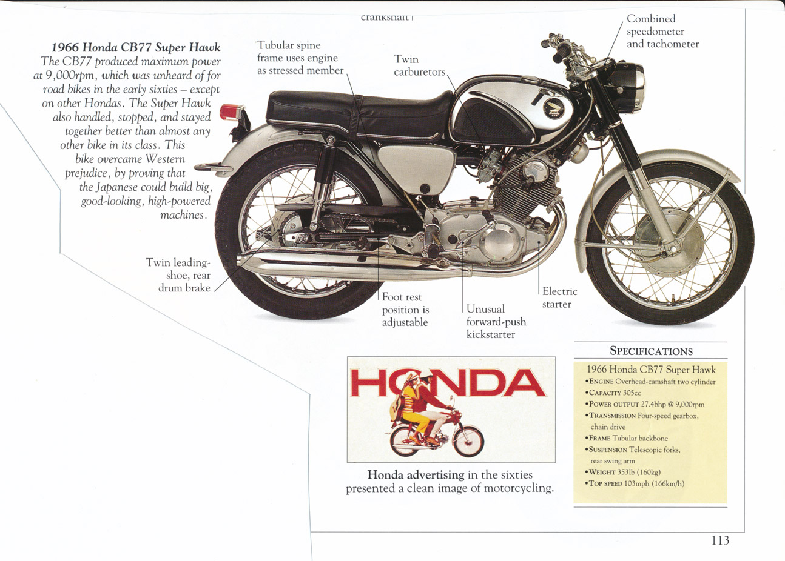

Yamaha 175CC CT1 (Fred) 1969 to 1998
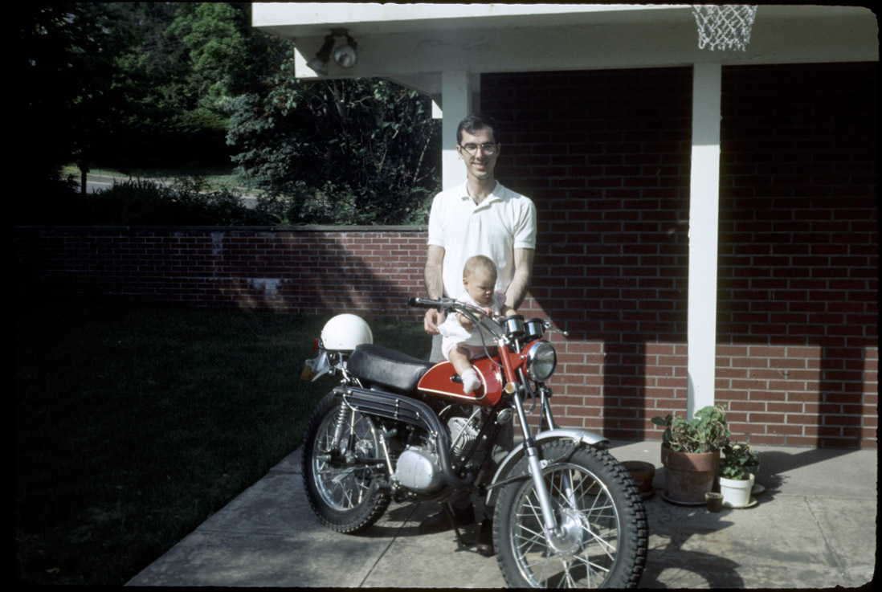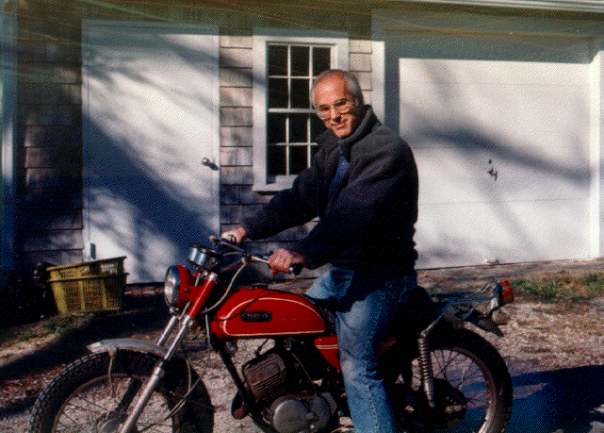

Yamaha 175CC CT1 (Carl) 196? to ????

FUTURE BIKES

On May 16, 2014, at 6:28 AM, "Frederick N. Chase" <fchase@gmail.com> wrote:

Looks a little like a Whizzer, but that "motor" is a battery.

http://www.wired.com/2013/11/icon-e-flyer/

Fred, "If I Recall Correctly"
When searching, try the two words Doodle Bug, in quotes (meaning that there're no words between) or the single word doodle-bug.

